25.51: a)
b) 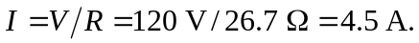
c) If the voltage is just 110 V, then 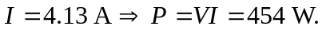
d) Greater. The resistance will be less so the current drawn will increase, increasing the power.

